Assignment 4
Name- Udayveer singh
Roll no.-1024150076
Batch-2O13

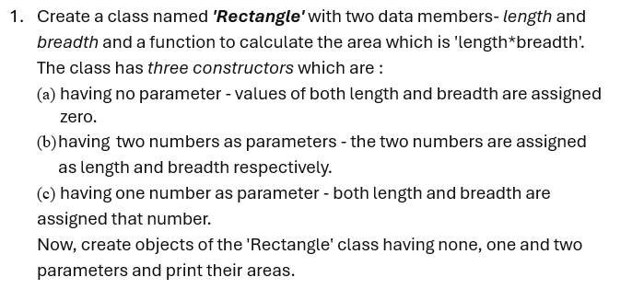
CODE-
#include <iostream>
using namespace std;

class Rectangle {
int length, breadth;

public:
Rectangle() {
length = 0;
breadth = 0;
}

Rectangle(int l, int b) {
length = l;
breadth = b;
}

Rectangle(int x) {
length = x;
breadth = x;
}

int area() {
return length * breadth;
}
};

int main() {
Rectangle r1;
Rectangle r2(5);
Rectangle r3(4, 6);

cout << "Area (no parameters): " << r1.area() << endl;
cout << "Area (one parameter): " << r2.area() << endl;
cout << "Area (two parameters): " << r3.area() << endl;

return 0;
}
OUTPUT-
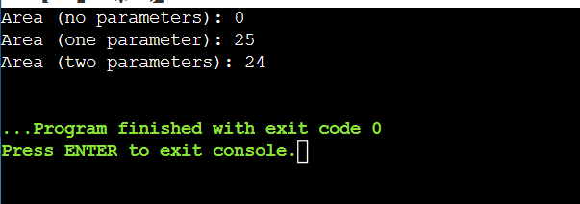

2. Redefine the above program by creating an array of objects of the class Rectangle and calculate area for each object calling different constructors. Also implement constructors with default arguments and destructor in this program.

CODE-
#include <iostream>
using namespace std;

class Rectangle {
private:
float length, breadth;

public:
Rectangle() {
length = 0;
breadth = 0;
cout << "Default Constructor Called\n";
}

Rectangle(float l, float b) {
length = l;
breadth = b;
cout << "Parameterized Constructor Called\n";
}

float area() {
return length * breadth;
}

// Destructor
~Rectangle() {
cout << "Destructor Called\n";
}
};

int main() {
Rectangle r[3] = { Rectangle(), Rectangle(3,4), Rectangle(5,6) };

for(int i = 0; i < 3; i++) {
cout << "Area of object " << i+1 << ": " << r[i].area() << endl;
}

return 0;
}
OUTPUT-
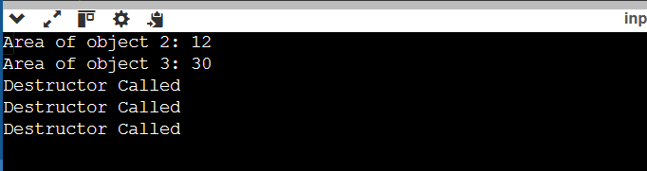

3. Verify the following about destructor by writing the program:
(i) Name should begin with tilde sign (~) and must match class name.
(ii) There cannot be more than one destructor in a class.
(iii) Destructors do not allow any parameter.
(iv) They do not have any return type, just like constructors.
Note:
When you do not specify any destructor in a class, compiler generates a default destructor and inserts it into your code.

CODE-
#include <iostream>
using namespace std;

class Test {
public:
Test() {
cout << "Constructor Called\n";
}
~Test() {
cout << "Destructor Called\n";
}
};

int main() {
Test t1;
return 0;
}
OUTPUT-
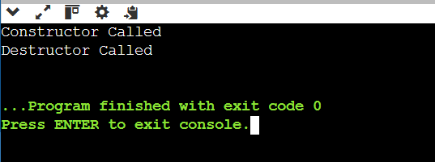

4. Implement dynamic memory allocation. Use new and delete keywords.
(For integer variable, float variable, integer array, float array, class objects, Array of Objects)

Code-
#include <iostream>
using namespace std;

class Demo {
public:
int x;

Demo() {
x = 10;
cout << "Object Created\n";
}

~Demo() {
cout << "Object Destroyed\n";
}
};

int main() {

int *p = new int;
*p = 5;
cout << "Integer: " << *p << endl;
delete p;

float *f = new float;
*f = 3.14;
cout << "Float: " << *f << endl;
delete f;

int *arr = new int[3];
for(int i=0;i<3;i++) arr[i] = i+1;
cout << "Integer Array: ";
for(int i=0;i<3;i++) cout << arr[i] << " ";
cout << endl;
delete[] arr;

float *farr = new float[3];
for(int i=0;i<3;i++) farr[i] = i + 0.5;
cout << "Float Array: ";
for(int i=0;i<3;i++) cout << farr[i] << " ";
cout << endl;
delete[] farr;

Demo *obj = new Demo();
delete obj;

Demo *objArr = new Demo[2];
delete[] objArr;

return 0;
}
OUTPUT-
